# System Diagrams

## 1. Use Case Diagram

This diagram illustrates how different users interact with the e-commerce system.

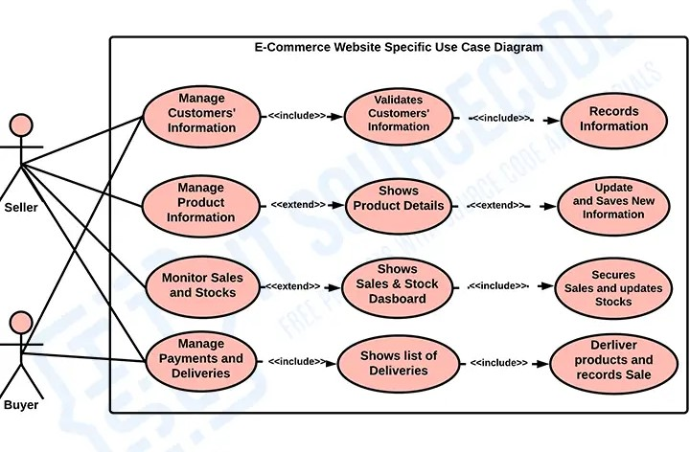

## 2. Sequence Diagram

This diagram represents the sequence of interactions between users, the system, and external services.

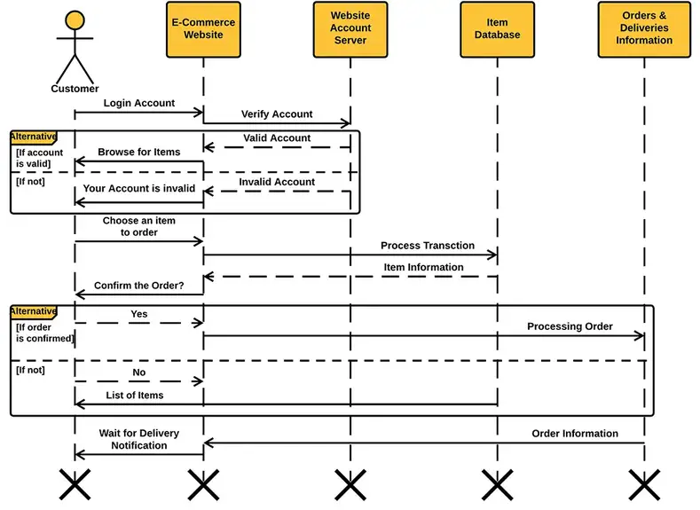

## 3. Data Flow Diagram (DFD)

This diagram shows the flow of data between users, processes, and databases.

Level_0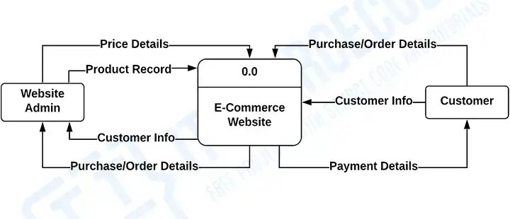Level_1

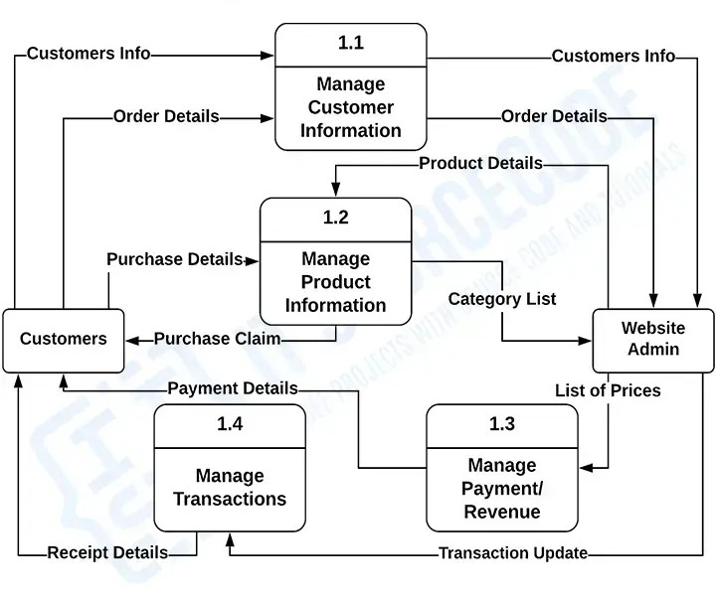

## Level_3

## 

## 4. Activity Diagram

This diagram describes the step-by-step process a user follows within the system.

Level_0

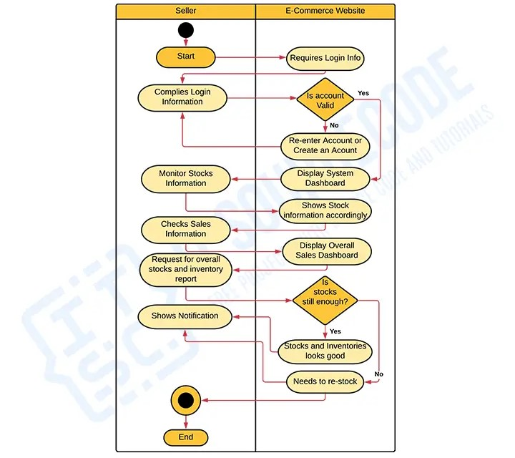

## Level_1

## 

## 5. Class Diagram

This diagram outlines the structure of the system by defining the objects, attributes, and relationships.

